**PART I (Time Spent: 3 hrs)**

1. **Solution**:

Decision tree has many algorithms to implement it, such as ID3, CART, C4.5, those are famous one. They all use max Information Gain or min Entropy to decide the split criteria.

Information Gain = Entropy(parent) - Weighted Sum of Entropy (Children)

From the above equation, the Entropy(parent) is a fixed value, if we minimize the Weighted Sum of Entropy (Children), it equivalents to maximize the Information Gain.

So, the algorithm will choose the value that max Information Gain or min Entropy to split the tree. That means each time, when the tree decides the split note, it will run all the features to calculate Information Gain.

In our case, Eyes attribute needs to split first.

1. **Solution:**

No of positive class labels = 3

No of negative class labels = 3

So, the starting entropy is given by p = 3/6, n = 3/6

Info (D) = -3/6 log (3/6) – 3/6 log (3/6)

= -1/2 X -1 – ½ X -1

= 1

Info (height)short = -1/3(1/3) – 2/3 (2/3)

= -1/3 (- 1.58496) – 2/3 (- 0.58496)

= 0.52832 + 0.38997

= 0.91829

Info (height)short = -2/3(2/3) – 2/3 (2/3)

= – 2/3 (- 0.58496) -1/3 (- 1.58496)

= 0.38997 + 0.52832

= 0.91829

Expected Entropy for Height is then given by

3/6 X 0. 91829 + 3/6 X 0.91829

= 0.459145 + 0.459145

= 0.918229

So, **Gain(height)** = 1 - 0.918229 = 0.082

Info (hair)blonde = -1/2(1/2) – 1/2 (1/1)

= -1/2 (- 1) – 1/2 (- 1)

= 1/2 + 1/2

= 1

Info (hair)dark = -2/3(2/3) – 1/3 (1/3)

= -1/3 (- 0.58496) – 1/3 (- 1.58496)

= 0.38997 + 0.52832

= 0.91829

Info (hair)gray = -1/1(1/1) – 0 (0)

= -1 X 0

= 0

Expected Entropy for hair is then given by

2/6 X 1 + 3/6 X 0.91829 + 1/6 X 0

= 1/3 + 0.459145 + 0

= 0.79248

So, **Gain(hair)** = 1 - 0.79248

= 0.20752

=0.21

Info (Eyes)blue = - 3/4(3/4) – 1/4 (1/4)

= -3/4 (- 0.415037) – 1/4 (- 2)

= 0.31128 + 0.5

= 0.81128

Info (Eyes)brown = - 0(0) – 2/2 (2/2)

= – 0

= 0

Expected Entropy for eyes is then given by

4/6 X 0.81128 + 2/6 X 0

= 2/3 X 0.81128

= 0.54085

So, **Gain(eyes)** = 1 - 0.54085

= 0.45914

= 0.46

**Figure 1: Decision Tree**

blue brown

dark blonde dark gray

PART II

tall short tall short short tall

-

-

-

+

+

+

1. **Solution:**

|  |  |  |  |  |
| --- | --- | --- | --- | --- |
| **Example** | **height** | **hair** | **eyes** | **class** |
| **X7** | **tall** | **dark** | **blue** | **+** |
| **X8** | **short** | **dark** | **blue** | **+** |
| **X9** | **tall** | **blonde** | **blue** | **+** |
| **X10** | **short** | **blonde** | **blue** | **-** |
| **X11** | **short** | **dark** | **brown** | **-** |
| **X12** | **tall** | **gray** | **brown** | **-** |

**PART II (Time Spent: 3 hrs)**

**Lesson 1:**

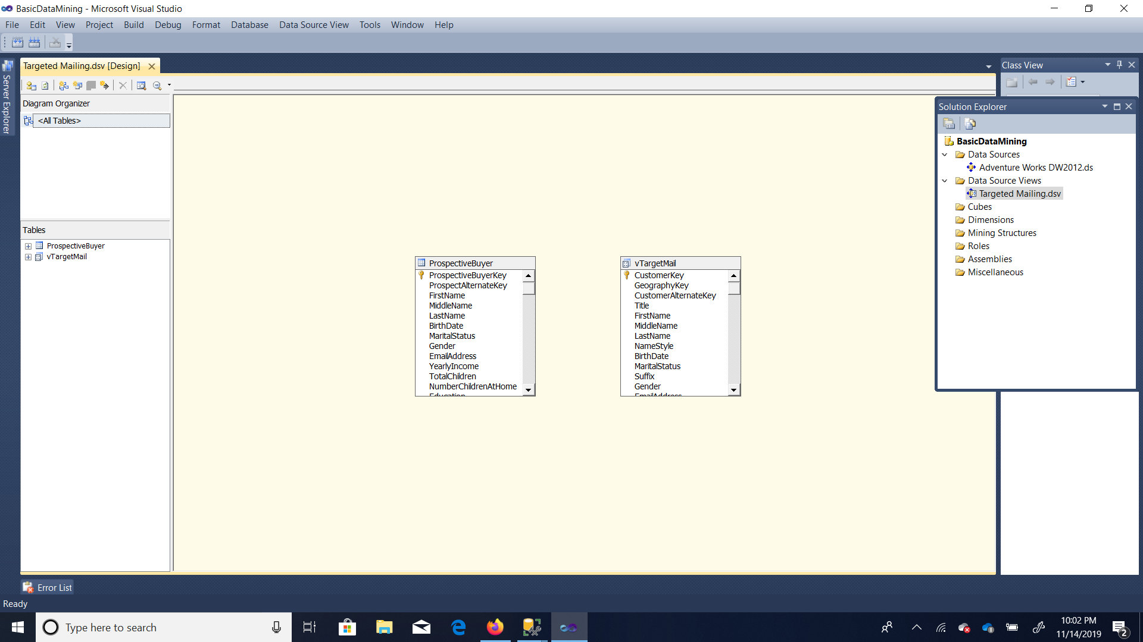

Lesson II:



Lesson III

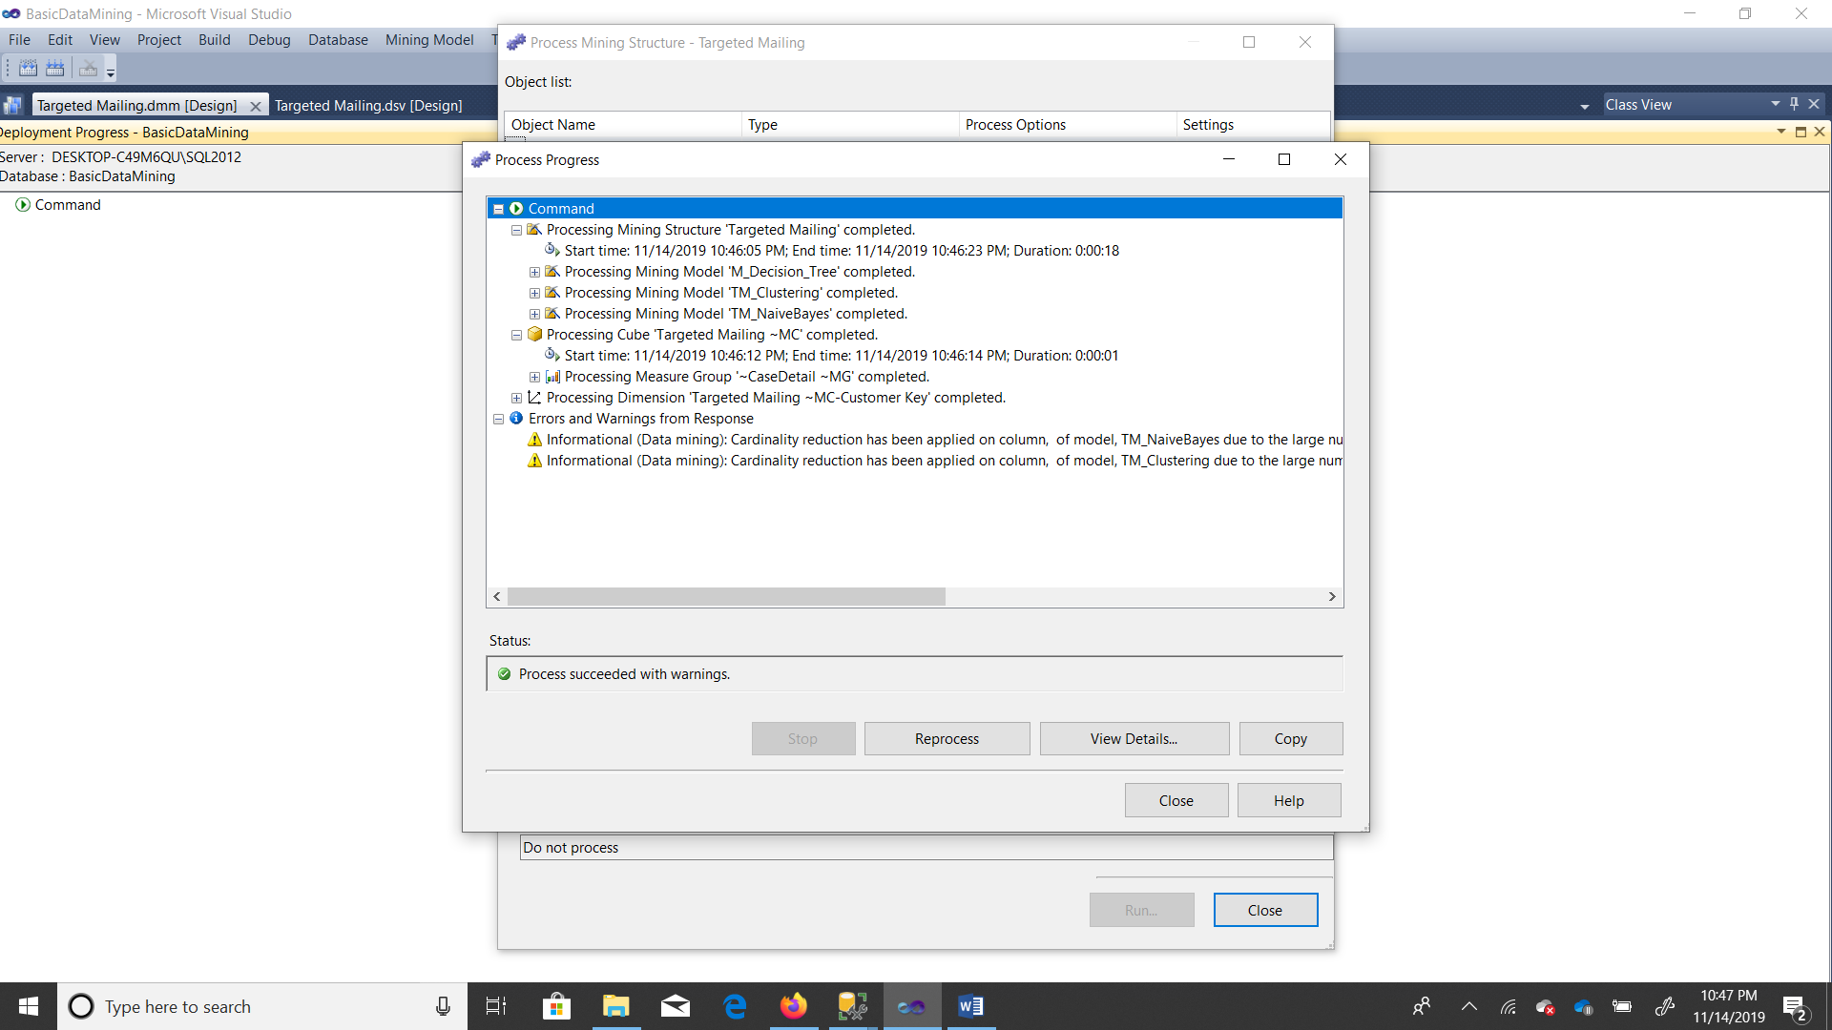

Lesson IV:

Decision Tree:

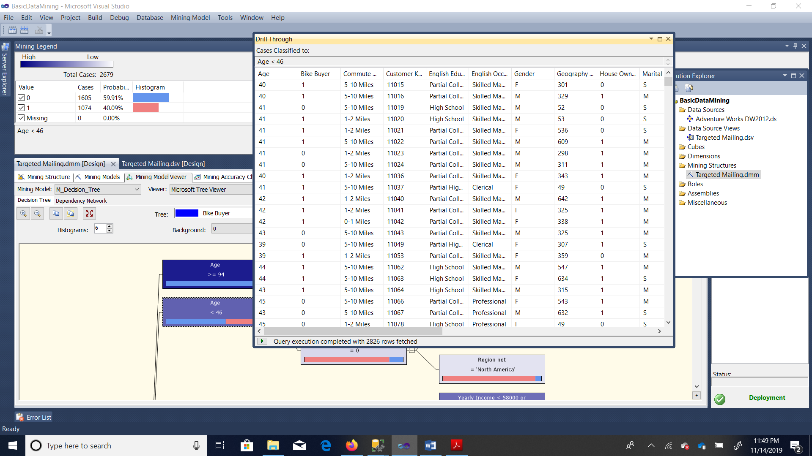

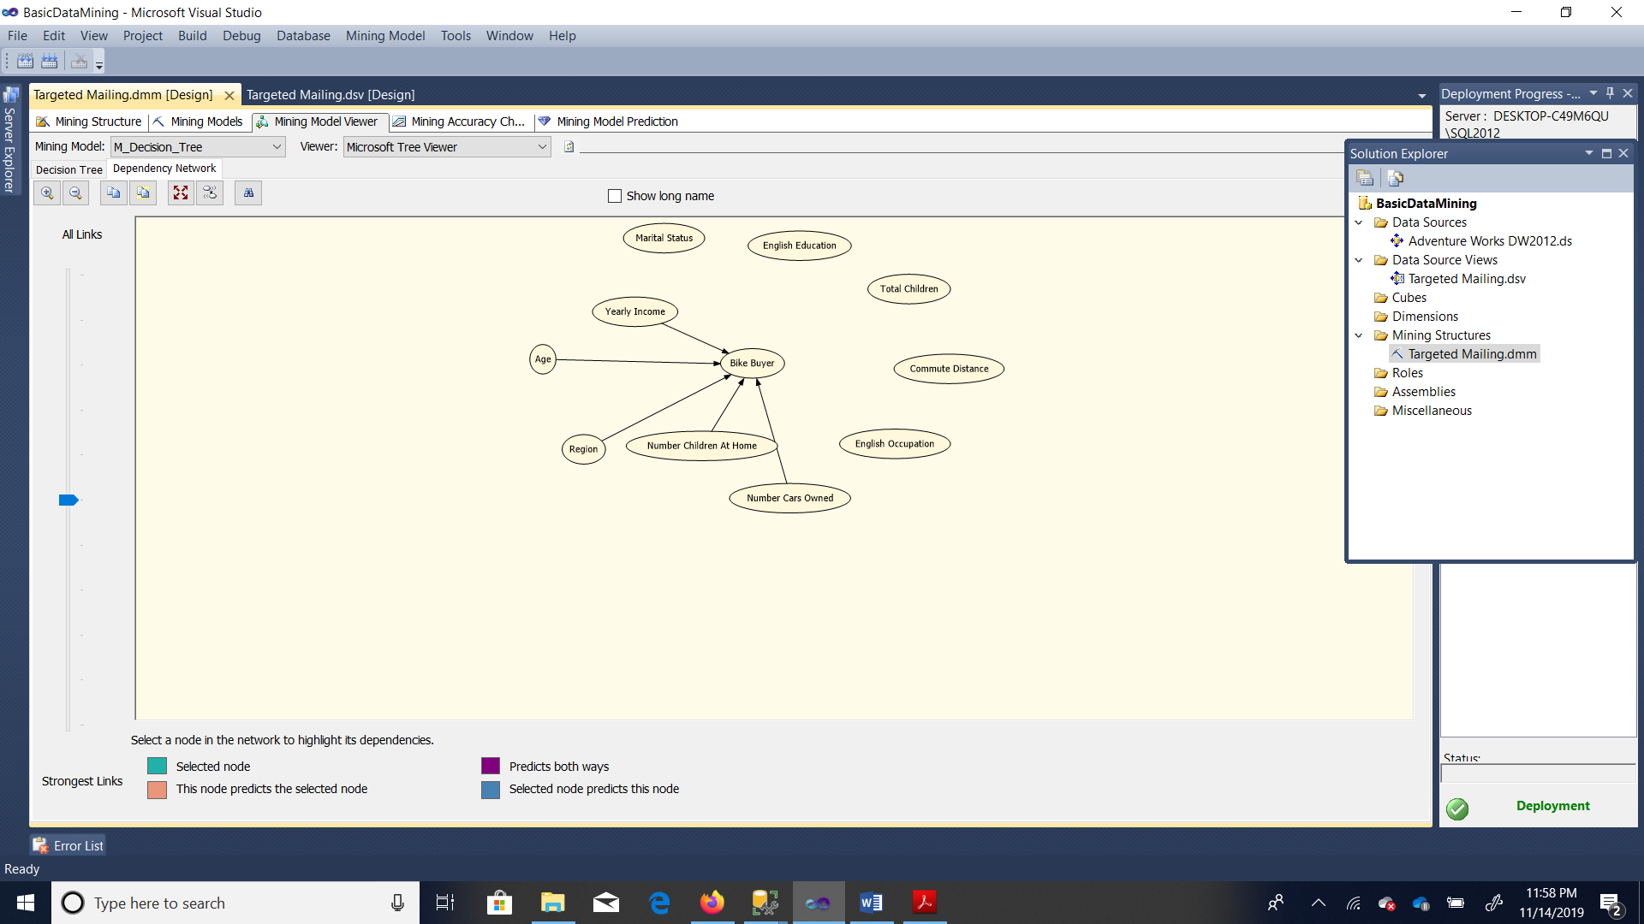

Dependency Network tab for the Decision Tree model

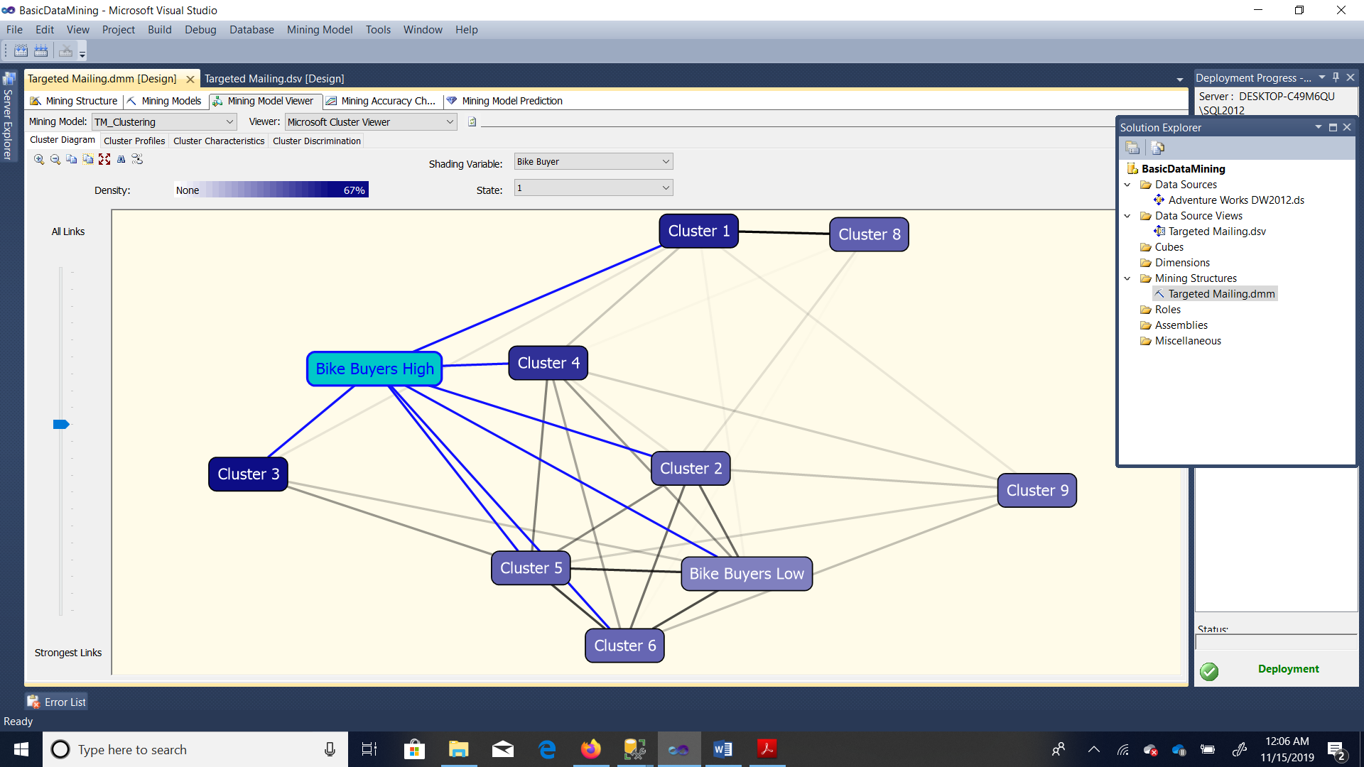



Naïve Beyes

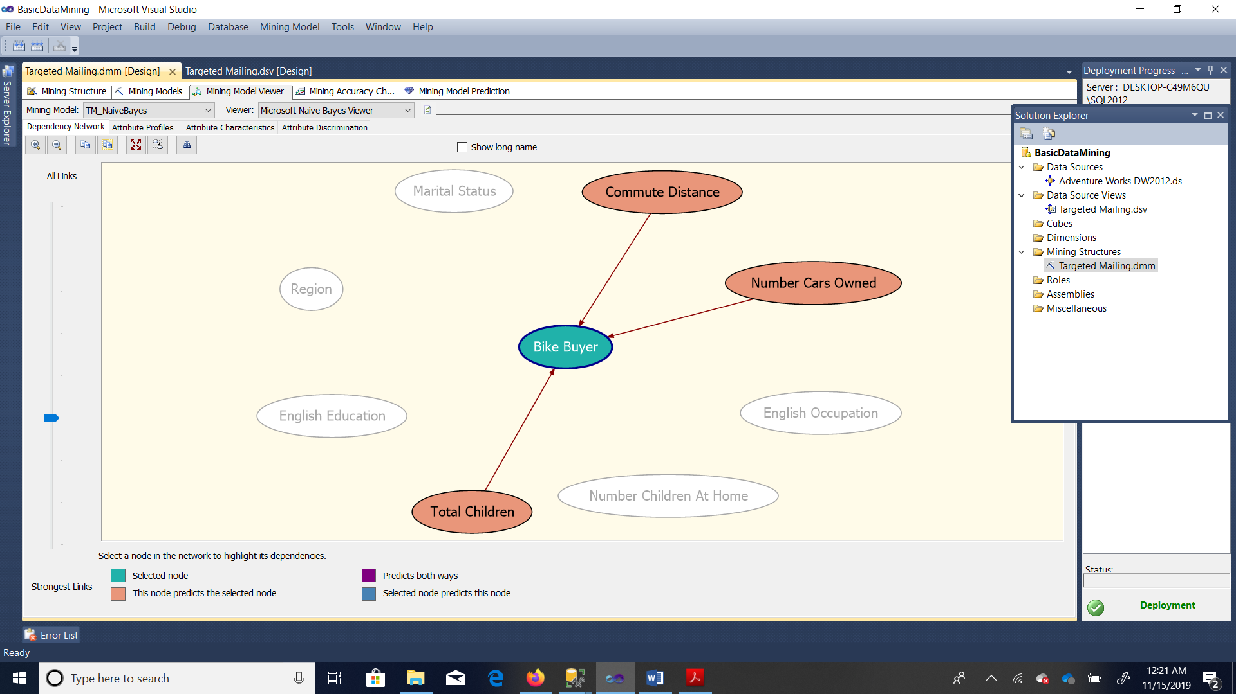

Naïve Beyes Attribute Characteristics

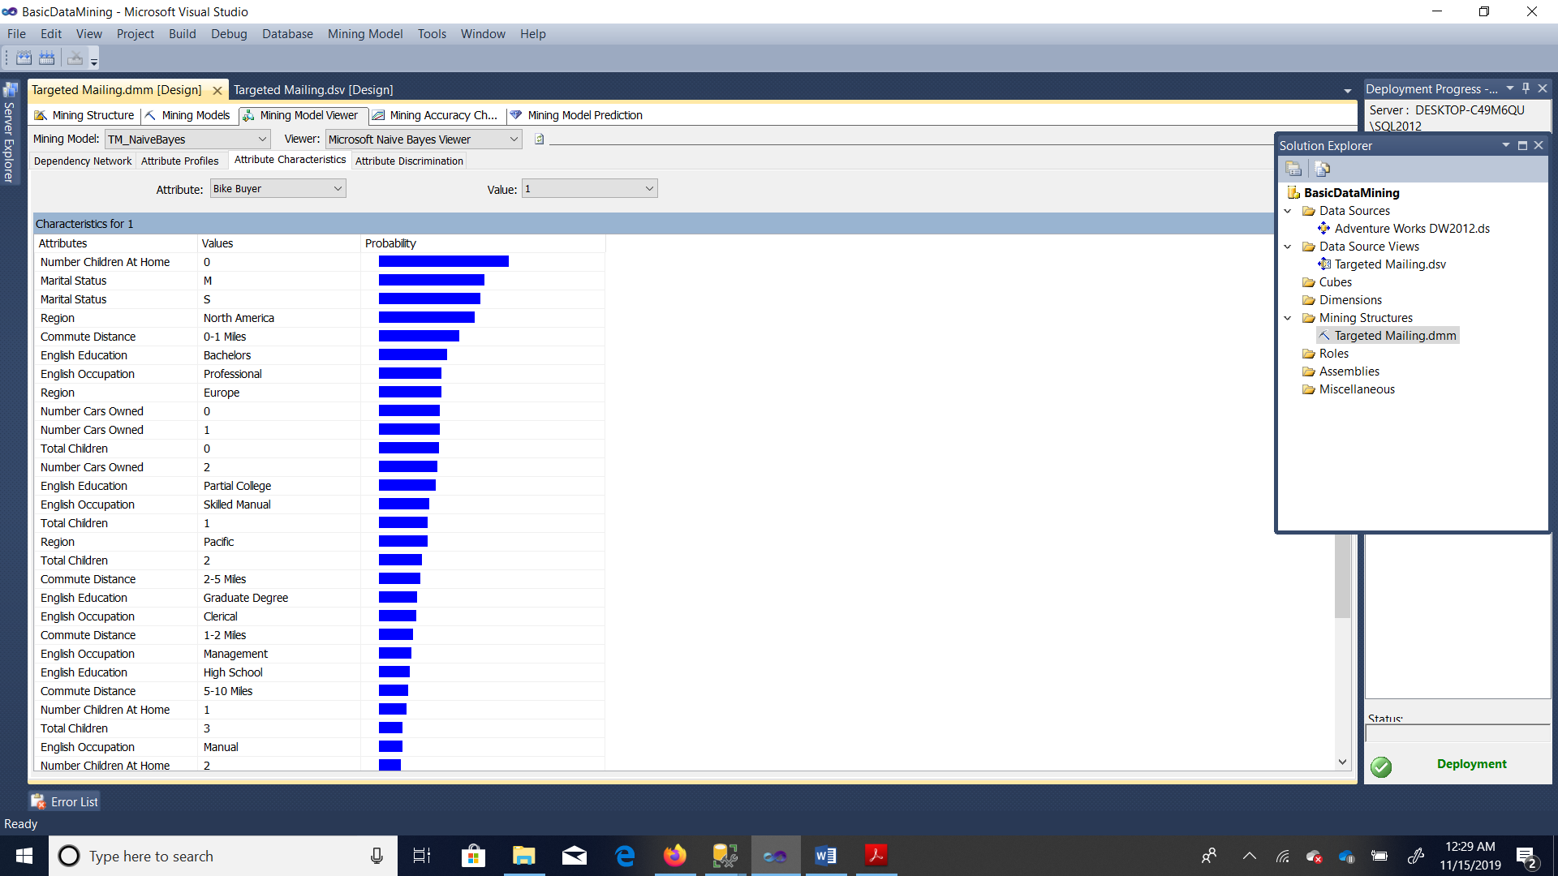

Naïve Beyes Attribute Discrimination

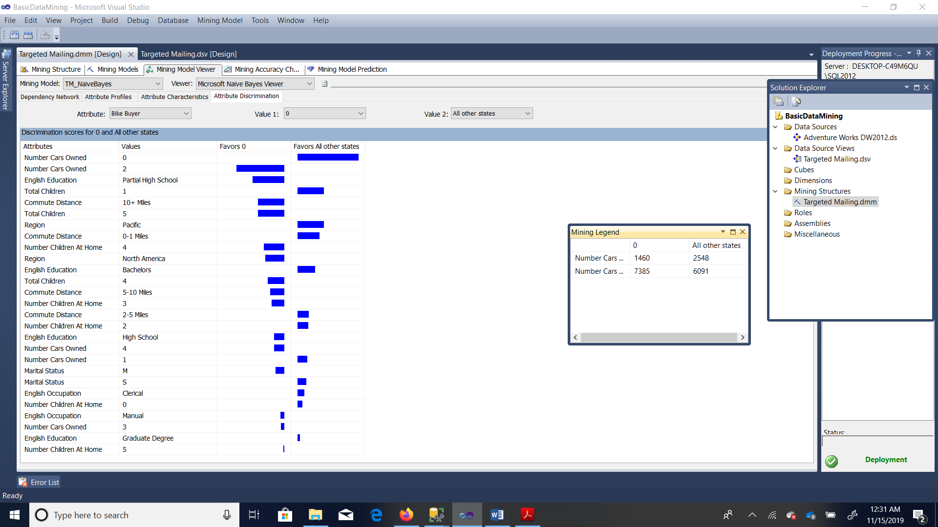

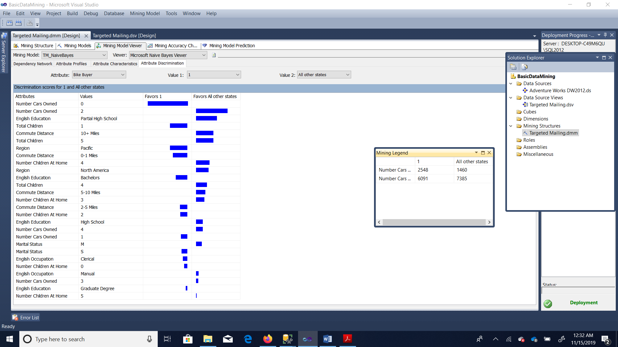

3.

Lesson V:

TM_Decision_Tree

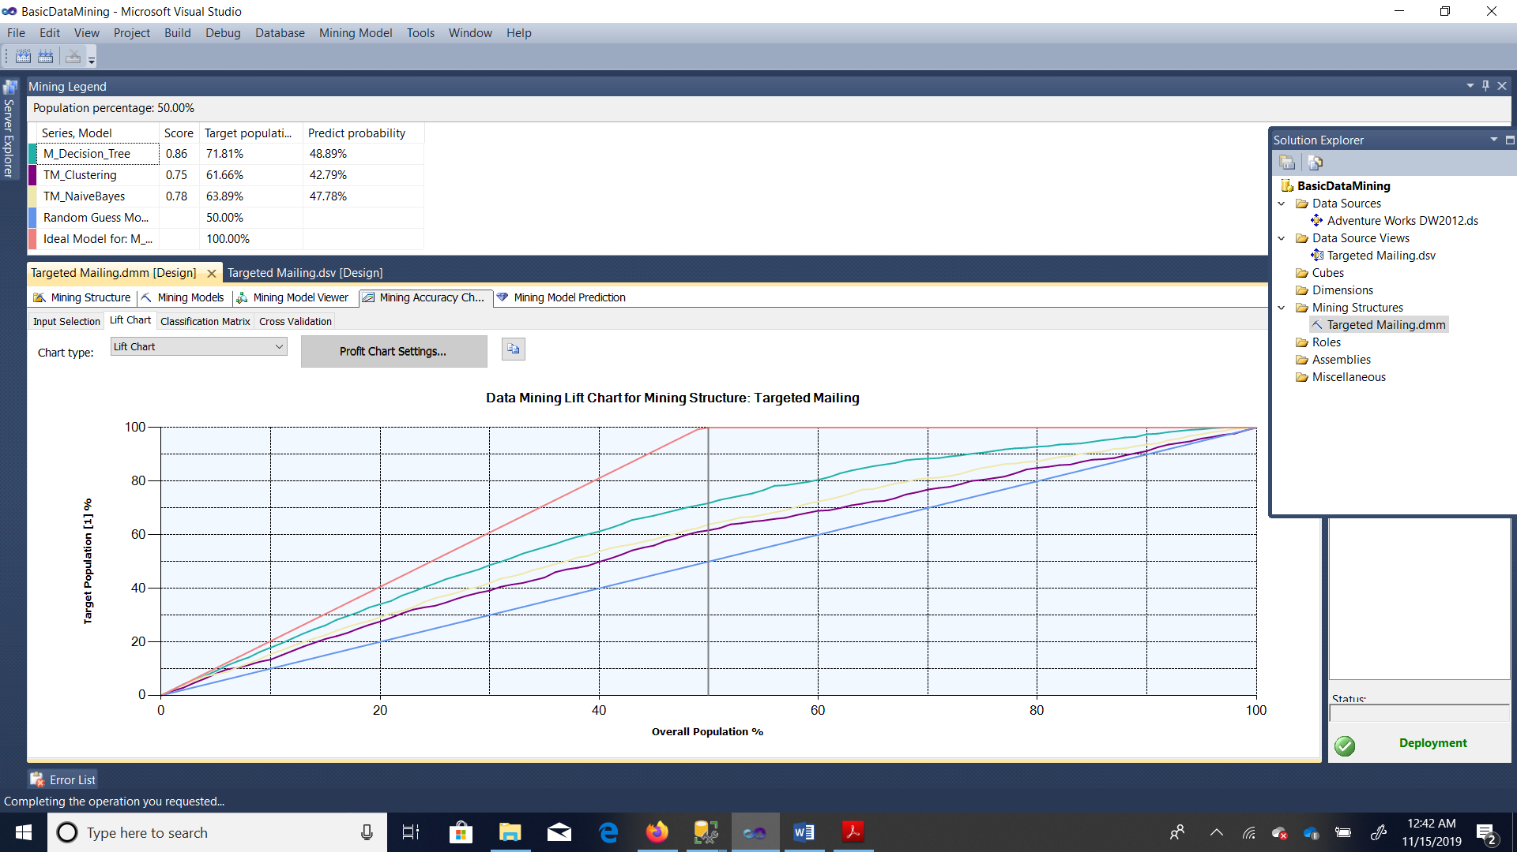

TM_Decision_Tree_Male



TM_Decision_Tree_female

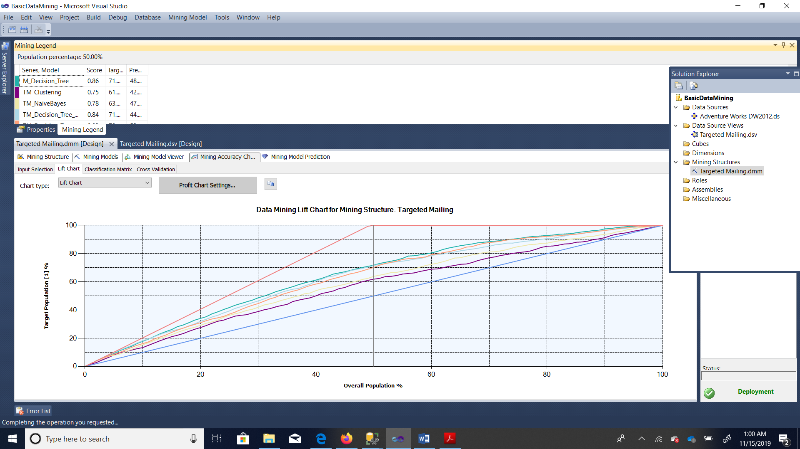

4.

Lesson Vi:

